**Sort Questions and Answers**

Q.1 What is Routing and on which OSI layer it happens?

The Path taken by traffic in a network or between networks is called route and this process is called routing which takes place in the network layer.

Q.2 Write any two advantages of static routing.

1. Admin has control of the network.
2. Is does not put that much load on the router.

Q.3 What happens when default routing is applied in networks other than stub networks?

Default routing is used to direct the packets with unknown destination. If the destination is not known the packet is hops to the next router using the default route which might know its destination.

Q.4 What DCE & DTE stand for?

**DTE:** Data Terminal Equipment

**DCE:** Data Communications Equipment

Q.5 What OSPF stands for and what is its Metric/Cost?

**OSPF:** Open Shortest Path First

It divides the reference bandwidth by interface bandwidth. Reference bandwidth is considered to be 100Mbps.

Q.6 What is the difference between subnet mask and wildcard mask?

Subnet mask is used to show which portion describes the network and which portion describes the host. Wild card mask is inversion of the subnet mask which shows the number of hosts in a subnet.

Q.7 Differentiate Distance Vector and Link State routing protocols.

In distance vector the router knows the whole system and it uses Bellman Ford Algorithm whereas, in link state routing the router only knows its neighbors and it used Dijikstra Algorithm.

Q.8 Write one example each of Distance Vector and Link State.

**Distance Vector:** RIPv1

**Link State:** OSPF

Q.9 Why is ACL and its Types?

ACL (Access Control List) is used as an extra layer of security. It works a firewall which controls the flow of traffic in and out of the subnets. You can configure ACL to improve the security if your network.

Types:

1. Standard ACL
2. Extended ACL
3. Named ACL

Q.10 Where we can apply ACL?

ACL can be applied at outbound, inbound and VCL. It can be applied on arriving and leaving ends but it cannot be applied on internal traffic.

**Step no: 1.** Use 187.200.1.0/24 address and perform subletting first.

Perform OSPF and submit screenshots of all the steps and outputs.

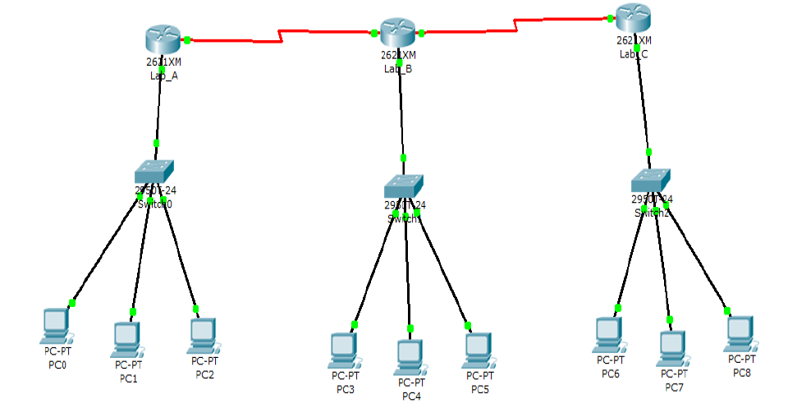

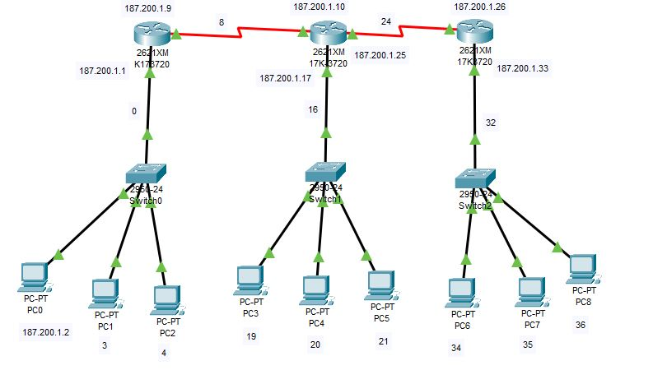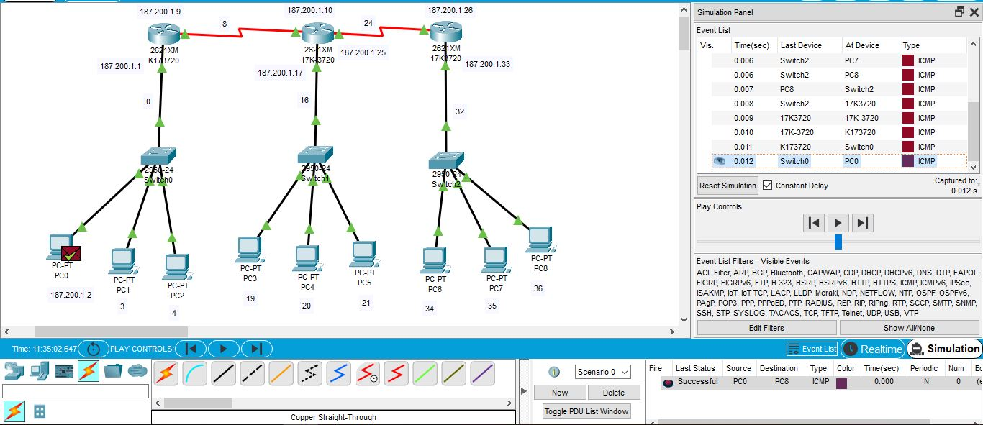

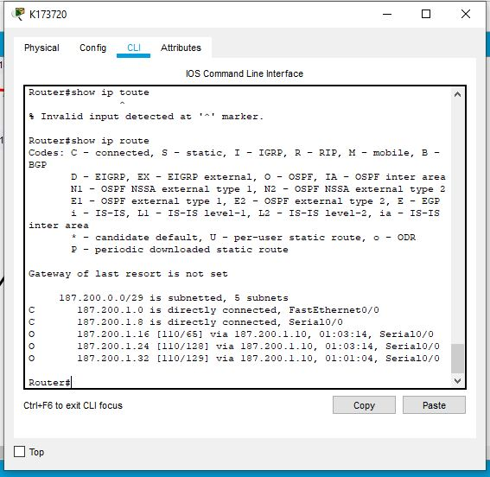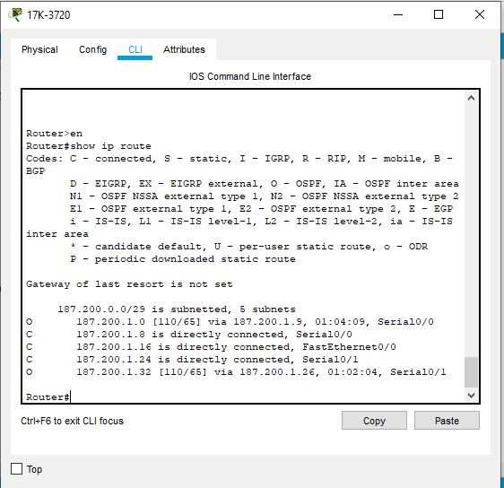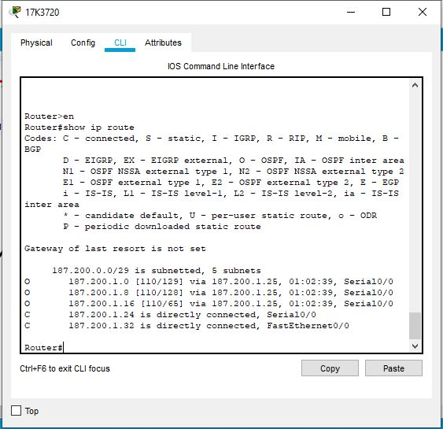

**Step no: 02**. Perform ACL

1. 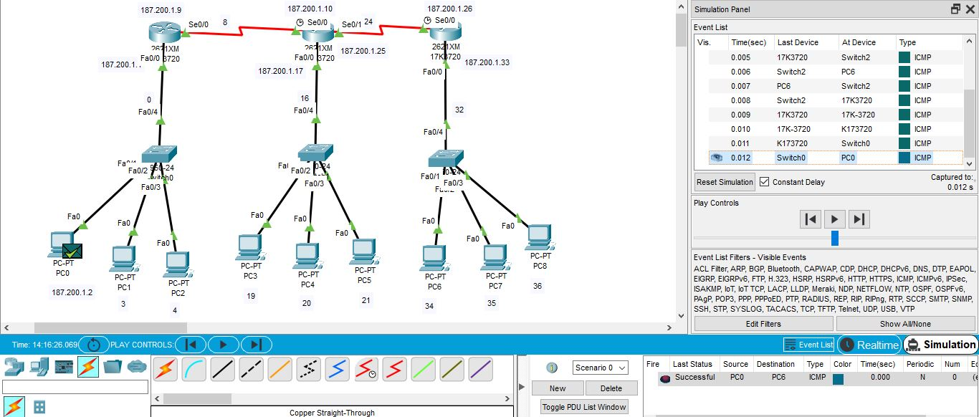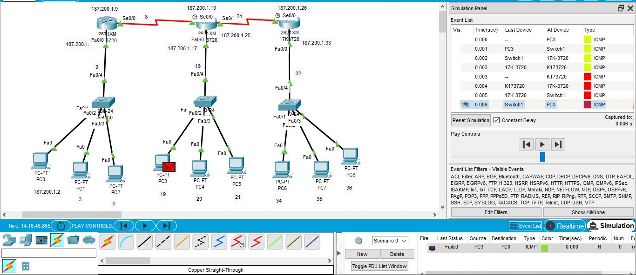Lab A only wants to communicate with Lab C.

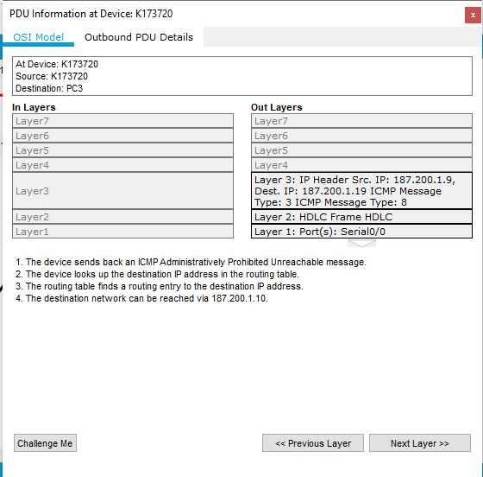

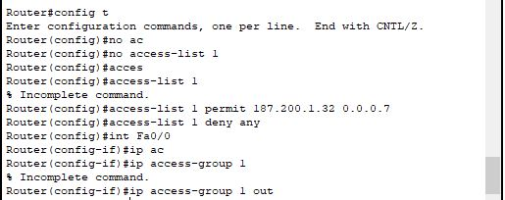

1. Lab C only wants to accept traffic/communicate with PC3 in the Lab B.

